mkdir and goto :

=> mkdir path/to/dir/dir_name && cd $_

Whenever you don't understand or want to know more about a command, program, topic, or utility you can just type **man <topic>** at the command line.

When referring to cases  where the user has to make a choice of what to enter (e.g. name of a program or file), we use the short hand 'foo' to represent <insert file name here>.

Linux has been created in 1991 by Linus Torwalds. Android is built on top of Linux. Linux has originally been built to be an open source version of UNIX.

**Distribution families for Linux**

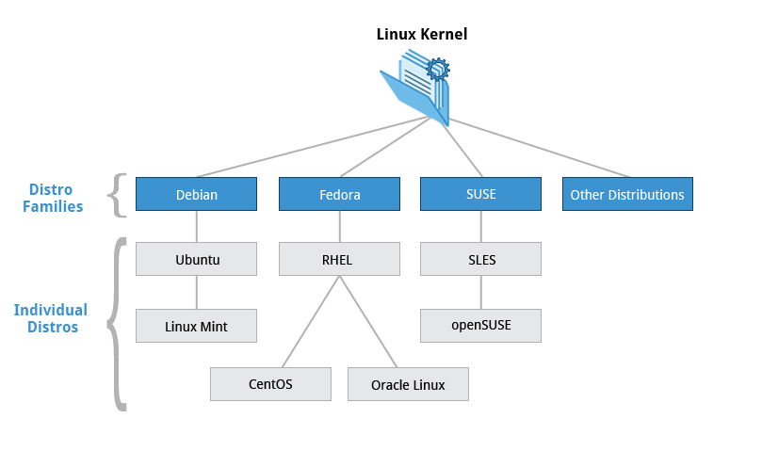

**Fedora**  is the basis of centOS, which is used a lot in Linux training, mostly because the release cycle is slightly longer than for other versions.

**Debian** is upstream for ubuntu. Ubuntu has been widely used for cloud deployment.

**GNOME** is a graphic environement, it’s a different thing than ubutnu or centos, it completes them.

**Linux concepts**

Kernel: Brain of linux, glue between hardware and operation

distribution: Collection of software making up a Linux OS

boot loader: Program that boots the operating system. (GRUB, ISOLINUX)

service: program that runs as a background process.

file system: method for storing or organizing files on Linux

X Window system: Graphical subsystem on nearly all Linux systems

desktop environment: GUI on top of the operating system.

command line: Interface to tape in commands.

A distribution consists in the Kernel plus a myriad of additional programs:

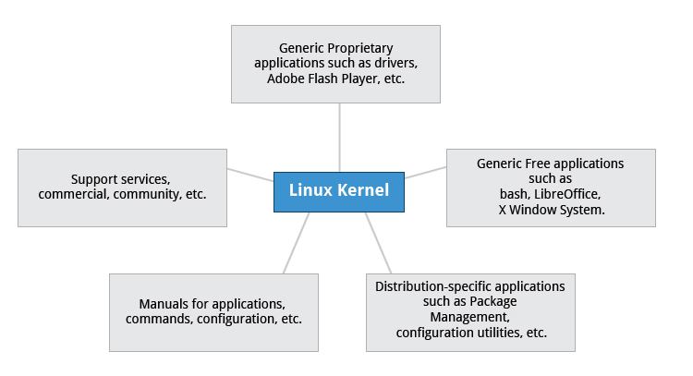

**CentOS** is a popular free alternative to **Red Hat Enterprise Linux (RHEL)**. **Ubuntu** and **Fedora** are popular in the educational realm. **Scientific Linux** is favored by the scientific research community for its compatibility with scientific and mathematical software packages. Both **CentOS** and **Scientific Linux** are binary-compatible with **RHEL**; i.e., binary software packages in most cases will install properly across the distributions.

**Boot loader process**

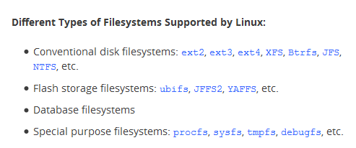

A partition is a logical part of the disc, a **filesystem** is a way of storing and organizing files on a partition.

Here is what happens when you boot your computer

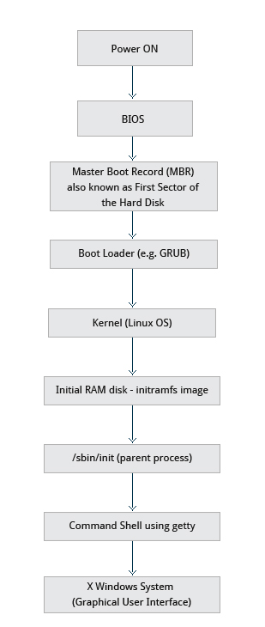

You will choose the Linux distribution depending on your needs. Things to be considered are, the storage space available on the machine (android = smaller than server for eg), support and customization provided by the issuer, life cycle.. Here is how the distributions are normally used to the best of their abilities.

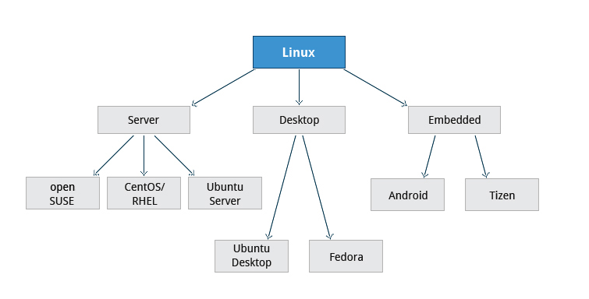

**Partitions**

A partition is a zone in the disk where are stored files of the same “family”. Inside a partition, filesystems (which are methods of organizing storage) are implemented to organize those files together.

Partitions are usually set up during the installation process.

* le disque serait le meuble lui-même, ou encore chacune des étagères de ce meuble ;
* la partition est une encyclopédie. On a une encyclopédie sur l'histoire, une autre sur la géographie, un dictionnaire, un guide de l'auto, etc. qui contiennent chacune des informations selon leur domaine de prédilection ;
* le système de fichiers est un moyen de retrouver l'information dans chacune des encyclopédies (numéros de pages, codes de couleur, classement par dates ou marques, etc.).

How a Linux distr looks like once installed on a windows machine :

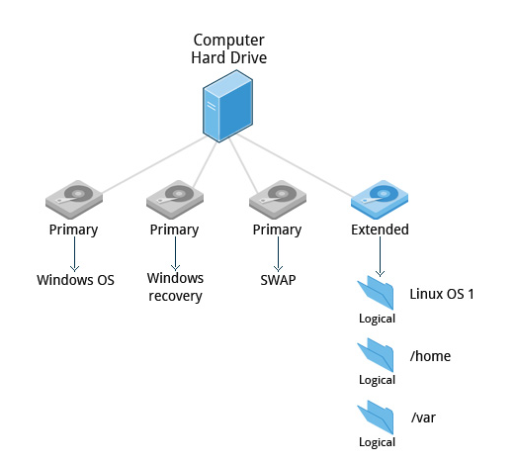

Many installers can do an installation completely automatically, using a configuration file to specify installation options. This file is called a **Kickstart** file for **Fedora**-based systems, an **AutoYAST** profile for **SUSE**-based systems, and a **preseed file** for the **Debian**-based systems.

A standard installation will erase all data previously present on the machine, so try out these alternative methods instead:

1. Re-partitioning your hard disk to free up enough room to permit dual boot (side-by-side) installation of Linux along with your present operating system.
2. Using a host machine hypervisor program (such as VMWare's products or Oracle Virtual Box) to install a client Linux Virtual Machine.
3. Booting off of and using a Live CD or USB stick and not writing to the hard disk at all.